**Simon Crawford-Phillips**

Conductor/Director/Pianist

*“The conductor Simon Crawford-Phillips proved to be an enthralling figure both as a musician and a stage persona… energetic, fast, constantly and thrillingly on the front foot.”* (Västmanlands Tidning).

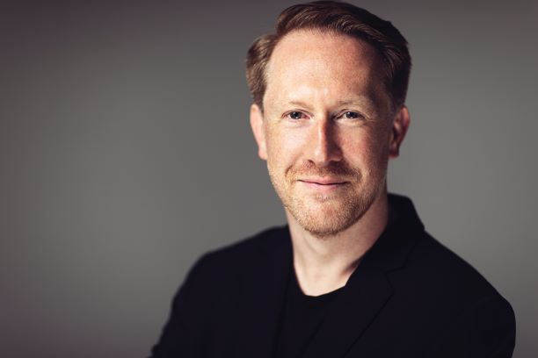Simon is a multi-festival director, conductor and renowned pianist.

A creative programmer with a passion for championing contemporary repertoire he regularly collaborates as a chamber musician with artists such as Daniel Hope, Lawrence Power, Roderick Williams and Anne Sofie von Otter in repertoire from Haydn and Schumann to Adès, Byström, Dean and Reich. Simon’s own ensembles include The Kungsbacka Piano Trio and Stockholm Syndrome Ensemble. He is the Artistic Director of the Change Music Festival in Sweden, Co-Artistic Director of the Wye Valley Chamber Music Festival in the UK as well as Chief Conductor & Artistic Advisor of Västerås Sinfonietta. Simon’s spicy and eclectic programming is reflected in an extraordinarily varied career as a conductor/director alongside his chamber and solo engagements.

This season’s conducting debuts include the Helsinki Philharmonic in ‘The Fearless’, a programme including music by Tower, Copland and the Finnish premiere of Sandström’s Cello Concerto with Torleif Thedéen as well as two visits to the Scottish Chamber Orchestra, one in a shared programme with Pekka Kuusisto. Opera projects include two Menotti operas at the Academy in Gothenburg and Simon returns to orchestras such as the Swedish Radio Symphony, Swedish Chamber and Nordic Chamber. At the keyboard Simon will record two portrait albums with the Kungsbacka Piano Trio for BIS records in music by Sebastian Fagerlund and Daniel Börtz. This is followed by a trio album with Malin Broman and Rick Stotijn featuring a new trio by Britta Byström. Simon has recently launched a concert series in Stockholm - entitled ‘Musikaliska Möten’ (Musical Meetings), these dynamic events feature unexpected pairings of music with readings, film and other genres and are set in the heart of Stockholm at the unique ‘Musikaliska Kvarteret‘ - Stockholm’s oldest concert hall!

Simon’s last season saw his conducting debut with the Swedish Royal Opera in Britten’s *A Midsummer Night’s Dream,* which was Norman Lebrecht’s Opera of the week. The Svenska Dagbladet wrote “*The Swedish Royal Opera Orchestra under the direction of Simon Crawford-Phillips manage to reveal the myriad of temperament and structure that the music contains, without the dreaminess disappearing*”. Simon led the Royal Stockholm Philharmonic Orchestra for their pioneering ‘Philharmonic day’, conducted the world premiere of Börtz’s Violin ‘Concerto for One’ with Malin Broman and Norrköpings Symfoniorkester, the world premiere of Djuro Zivkovic’s violin concerto with Pekka Kuusisto and the Swedish Chamber Orchestra, performed the world premiere of a new double concerto with Tapiola Sinfonietta from Finnish composer Sauli Zinovjev written for Simon and Hugo Ticciati, as well as touring with Musica Vitae in a programme of Tippett, Wallen, Gershwin & Bloch.

Recent conducting engagements have included Gävle Symfoniorkester, Neubrandenburg Philharmonic Orchestra, Gothenburg Symphony, Uppsala Kammarorkester, Helsingborg Symfoniorkester, Dalasinfoniettan, Sinfonia Varsovia in Warsaw’s Lutosławski Chain Festival, and ‘*Wild Waves and Woods’* at Kings Place with Västerås Sinfonietta, Paul Watkins and Lawrence Power. He also made his debut with the Zurich Chamber Orchestra for an extensive European tour alongside Daniel Hope. Previously Simon was Conductor Fellow of the NDR Elbphilharmonie Orchestra, working alongside chief conductor Alan Gilbert. He has also assisted Daniel Harding, Alain Altinoglu and Stanislav Kochanovsky at the Verbier Festival.

In 2017 Simon was appointed Artistic Adviser and Chief Conductor of Västerås Sinfonietta. He has broadened the Sinfonietta’s reach and repertoire as well as recording a Mendelssohn Symphony cycle due for completion in 2026.

As a pianist, The Guardian says Simon has “*profound sensitivity and technical brilliance, achieving an* *expressive intensity that makes for compelling listening.”* He performs in premiere festivals and concert halls across Europe including Verbier, Schleswig-Holstein, Edinburgh, Gstaad and at Wigmore Hall where he appears regularly as pianist with the acclaimed Nash Ensemble (Ensemble-in-residence). Notable concerto debuts include the NHK Symphony Orchestra under the baton of Alan Gilbert, BBC Scottish Symphony Orchestra under Ilan Volkov and the Swedish Radio Symphony Orchestra directing from the keyboard. Upcoming performances include a US tour with Daniel Hope and further performances with Pekka Kuusisto, Lawrence Power and his own ensembles.

Additional regular collaborators include artists such as Colin Currie, Konstantin Krimmel, Anthony Marwood, Truls Mørk, Philip Moore, Anne Sofie von Otter, Torleif Thedéen, Roderick Williams and the Danish and Elias string quartets. Simon values every opportunity to learn directly from composers and has been fortunate to work alongside Britta Byström, Sofia Gubaidulina, Simon Holt, Colin Matthews, Steve Reich, Mark-Anthony Turnage and Huw Watkins.

As a prolific recording artist he has recorded for BIS, Channel Classics, DG, Deux-Elles, Harmonia Mundi, Hyperion, LSO Live, Naxos, Nonesuch, Signum Classics, Alba and DB Productions. In addition to radio and television broadcasts in Europe, Australia and Japan Simon has also presented concerts for Sweden’s classical music radio station P2.

His most recent release of Schubert together with Josephine Knight garnered 5 star reviews. Future releases include a Debussy portrait for Hyperion with the Nash Ensemble, Mendelssohn Symphonies with Västerås Sinfonietta and a Schubert/Kurtag album for BIS with long-time piano partner Philip Moore.

In demand as a teacher, Simon currently holds a position at the Gothenburg Academy of Music and Drama and a professorship at Mälardalen University. Guest teaching has included the Schymberg masterclasses in Sweden together with Anne Sofie von Otter, at Indiana University in Bloomington, the University of Colorado and for Accordi Musicali in Pescara. Simon was elected a Fellow of the Royal Academy of Music in 2010 and is a Steinway Artist. Simon Crawford-Phillips is managed worldwide by Percius [www.percius.co.uk](http://www.percius.co.uk).

This biography is valid for use until September 2025.

We update our biographies regularly. For the most up-to-date version please email [info@percius.co.uk](mailto:hannah@percius.co.uk)