Taylor Scott Davis
Composer/Orchestrator/Conductor

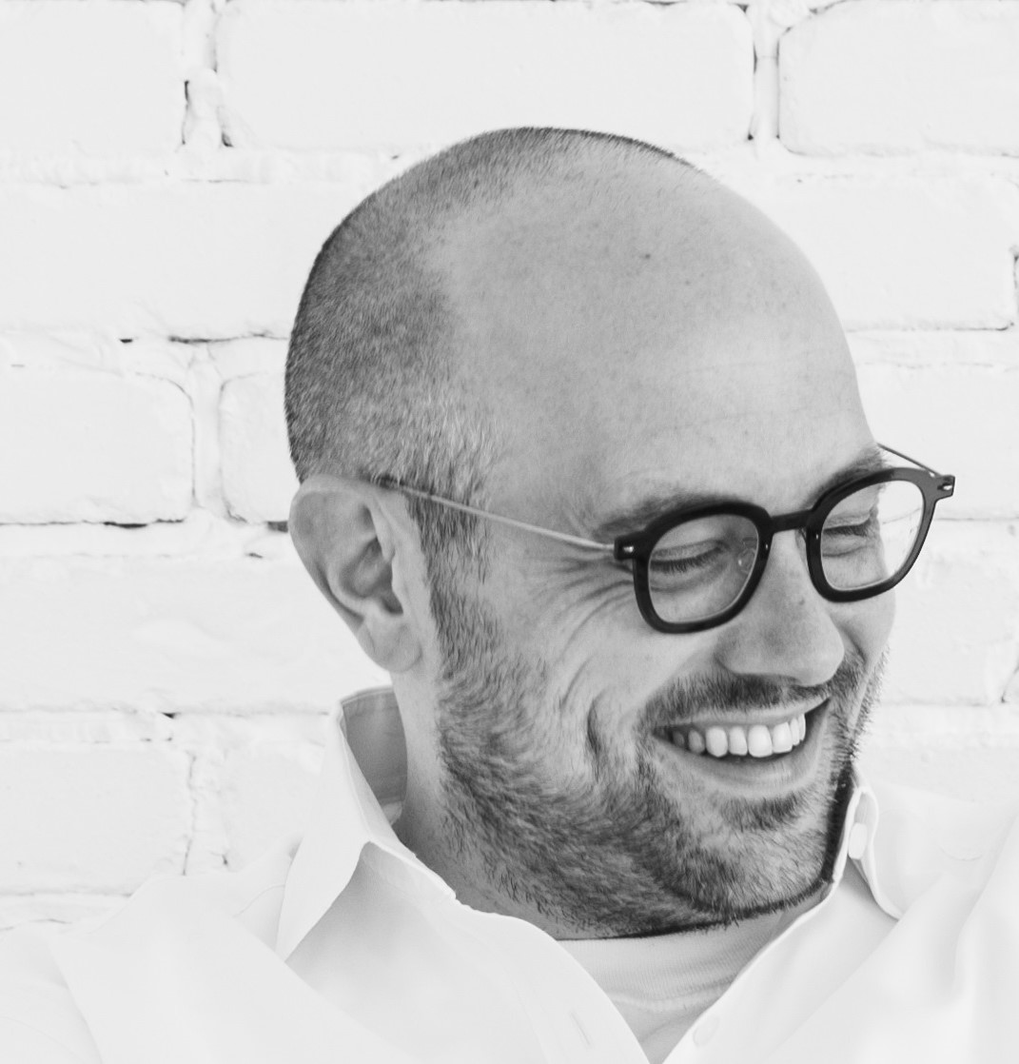
Hailed by the Wall Street Journal as penning “dreamy vocal lines” that “overlap and intensify to stunning effect”, Taylor Scott Davis’ “beguiling” (BBC Music Magazine) writing is much in demand by vocal groups and orchestras around the globe. His music has been described as “sonically luxurious”, memorable and inspiring of hope, and his belief in supporting collaboration, diversity and creating musical opportunities at all levels underpins all. From “full filmic blockbuster technicolour” to ravaging, soulful countermelodies and harmonies, Taylor’s music has a unique and timely voice.

“it’s the sumptuousness velvetiness of the textures, the propelling nature of the counterpoint, the contrasts of light and darkness, the prevailing exultancy – that really draw the listener’s attention” (Opera Today; ‘To Sing of Love: a Triptych’ for violin, choir, orchestra)
World Premieres and world premiere recordings formed the backbone of Taylor’s 2023-2024 season including notable first performances at Carnegie Hall, New York (Magnificat), Cadogan Hall, London (A Mosaic Mass - Cadogan) and at Sydney Opera House (Effortlessly from new concerto To Sing of Love: a Triptych) as well as significant releases on Decca Classics (Magnificat and five carol arrangements) and VOCES8 Records (new concerto To Sing of Love: a Triptych). Stardust has been premiered around the world by VOCES8 and will next appear on the group’s new Decca Classics release, Nightfall, in September 2024 - both an orchestrated and an a cappella arrangement of the piece are newly available.

Upcoming performances of Taylor’s works include by BBC Scottish Symphony Orchestra (Magnificat), by VOCES8 (Stardust), and by Seraphic Fire (Solstice). Upcoming commissions traverse a new Requiem Idyll including poetry by Siegfried Sassoon for The VOCES8 Foundation’s 20th anniversary which will be recorded for release and receive its world premiere in summer 2025, and significant works for Texas Master Chorale (The Poetry of Psalms) and churches across the US. Windphone, a new collaboration with renowned poet Charles Anthony Silvestri, is a contemporary oratorio inspired by the events of the 2011 Japanese Tsunami. Further projects also include A Migrant’s Mass which was inspired by the image of a particularly visceral drowning in the ongoing global immigration crisis. A Migrant’s Mass includes as its Credo text, a poem from a WWII concentration camp:

“I believe in the sun even when it is not shining.
I believe in love even when I do not feel.
Credo in unum Deum, Patrem omnipotentem,
factorem cæli et terræ, visibilium omnium et invisibilium.
I believe in God even when he is silent.”

Taylor has written and arranged for groups including the Grammy-winning choir Conspirare and regularly collaborates with VOCES8 as well as chamber ensembles such as the English Chamber Orchestra and symphony orchestras around the world. He often conducts his own performances with players from top London orchestras and Fort Worth, Dallas, and Houston symphony orchestras. Taylor’s ensemble music has been performed throughout the USA, Europe, South America, and South Africa, and his gaming music has been played around the world.

Published primarily by MorningStar Music/E.C.Shirmer across his own choral/orchestral series and as part of The VOCES8 Foundation’s series, Taylor has also been commissioned to write a series of four new Christmas Suites, edited by Bradley Ellingboe and Dr. Jennaya Robison for National Music Publishing USA. The first, Journey into Light, was premiered by the conservatory choirs at UMKC and the Topeka Symphony in December 2022 and is now available to perform as part of the Taylor Scott Davis Choir & Orchestra Series.

A Mosaic Mass – a concept created and curated by Taylor to promote multiple collaborative opportunities for composers and communities – had its first showcase at London’s Cadogan Hall in March 2024 and further collaborative iterations are in discussion around the globe. Alongside Taylor for its first edition, the four penning movements were composing friends Jocelyn Hagen, Ken Burton, Jim Clements and Paul Smith.

A Choral Christmas, Decca Classics’ 2023 Christmas album featured the world premiere recording of Taylor’s Magnificat and five new carol arrangements performed by the VOCES8 Foundation Choir and Orchestra, Jack Liebeck and Barnaby Smith and received a 5* review from BBC Music Magazine praising Taylor’s ”sparkling, roof-raising arrangements”. The lavish choral/orchestral production of the carols for LIVE From London was viewed/ received acclaim in over 180 territories across the media. O come, O come Emmanuel received over a quarter of a million views/listens in under a month, and Silent Night was a close second, receiving its world premiere on Classic FM radio and online.

Sing of Love: a Triptych, Taylor’s new concerto for violin, choir and orchestra, features in new album To Sing of Love and was reviewed by The Guardian as “sweetly glowing, beautifully coloured choral music”. Written for violinist Jack Liebeck, conductor Barnaby Smith and The VOCES8 Foundation Choir, the first movement of To Sing of Love is Effortlessly which received its World Premiere at Sydney Opera House to 5* reviews from Limelight and Artshub. Additionally, Jubilate Deo, Taylor’s recent new commission from the Fort Worth Chorale for orchestra and choir conducted by Dr. Karen Kenaston-French, was premiered to rave reviews and a standing ovation.

When not writing or conducting, Taylor Scott Davis serves as the Director of Music and Worship Arts at St. Andrew Methodist Church in Plano, Texas. He is a 2003 graduate and notable alumnus of Centenary College of Louisiana. Taylor earned a Bachelor of Sacred Music degree while studying conducting with Dr. Julia Brasher Thorn, as well as intensive courses with Dr. Sandra Willets, Dr. Ann Howard Jones, Paul Oakley, Alice Parker, and Jane Marshall. He has also studied composition with Dr. Eric McIntyre, Ms. Parker, and Ms. Marshall. In 2004, he became a Fellow of Melodious Accord.

“This was a programme of the ‘old’ made ‘new’. Taylor Scott Davis’ new arrangements of six traditional carols had a dazzling Romantic sweep which the Orchestra of 50 musicians – led by Jack Liebeck and the Carducci Quartet – and 24-strong Choir relished. Imaginative instrumentations, new chord progressions and textures, re-harmonisations and added melodic strands brought freshness to the familiar themes.” (Opera Today)

This biography is valid until January 2025.
We update our biographies regularly. For the most up-to-date version please email info@percius.co.uk

