Emily Sun
Violin

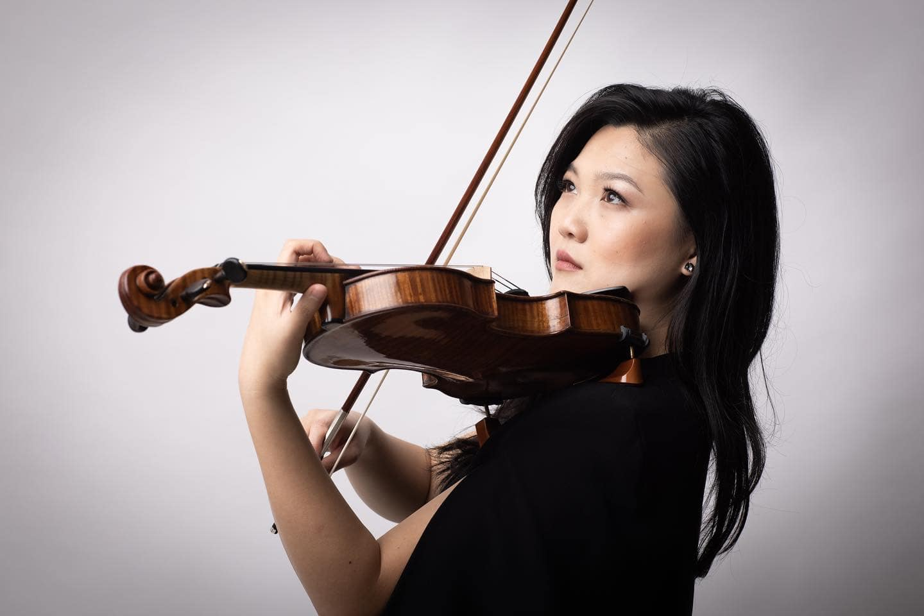
“Possessed of a superb talent” (The Australian) with “a searing and poetic tone” (The Guardian), “the flight’s of Emily Sun’s violin ... reaches heavenwards ... leaving us all in a long, stunned silence” (The Independent). Emily Sun’s powerful sound and compelling, captivating interpretations have won her international renown, just as her genuine connection with audiences and engaging presence have thrilled her growing host of supporters.
As much a chamber musician as a virtuoso, Emily originally shot to fame as a young soloist and media star in Australia, and internationally as a multi prize-winner. Now based in London and having performed with significant orchestras and in major concert halls around the globe, she is a fast-rising star with “a perfect balance of expressivity and formidable strength” (The Australian).
Emily’s residency as the Adelaide Symphony Orchestra’s Artist in Association 2023-2024, included the World Premiere of new concerto Fantasie im Wintergarten, commissioned from Elena Kats-Chernin by ASO for Emily, which received 5-star reviews and was hailed as “The memorable premiere of a new musical landmark” (5* Limelight Magazine) and “As always, Emily Sun gave a shining performance” (5* Artshub). She also gave the Australian premiere of Fazil Say’s Violin Sonata No 2 ‘Kaz Daglari’.
Emily releases her debut concerto album Film Fantasia in Autumn 2024 on ABC Classic which includes live recordings of Kats-Chernin: Fantasie im Wintergarten (recorded with ASO & Benjamin Northey), Korngold Violin Concerto and Williams Theme from Schindler’s List.
Upcoming debut performances include with BBC National Orchestra of Wales and conductor Gemma New giving the UK Premiere of Elena Kats-Chernin’s violin concerto, and Barber with Johannesburg Philharmonic and KwaZulu-Natal Philharmonic Orchestras. Season returns include Melbourne Symphony Orchestra, Australian Youth Orchestra and a recital at Sydney Opera House.
Recent orchestral performances include with the Sydney Symphony, West Australian Symphony, Tasmanian Symphony, and Melbourne Symphony with conductors such as Vasily Petrenko, Andrew Litton, Jaime Martin, Mark Wigglesworth, Johannes Fritzsch and Benjamin Northey. Emily has performed with the European Union Chamber Orchestra, Orchestre de Royal Wallonie and Orchestre de Chambre Namur in Europe; Arlington and Arizona Symphonies in the USA; Shanghai Youth Orchestra and Qingdao Symphony Orchestra in China.
Performances around the world include venues such as Sydney Opera House, Wigmore Hall, Royal Albert Hall, Tchaikovsky Great Hall Moscow, Auditorium du Louvre Paris, and Flagey Brussels. Emily was invited to perform at Buckingham Palace alongside Maxim Vengerov in the presence of HRH King Charles III, and at the Royal Palace of Brussels in the presence of the King and Queen of Belgium. Awards and prizes have included 2018 ABC Young Performers Award (Australia), the 2016 Royal Overseas League Music Competition (UK), and the Brahms (Austria), Yampolsky (Russia) and Lipizer (Italy) international violin competitions. She was a Young Concert Artist for the Tillett Trust, The Worshipful Company of Musicians and City Music Foundation.

Recent chamber recitals include Music in the Round, a duo partnership with pianist Anna Tilbrook, a duo with Joseph Havlat and a residency at the Australian Chamber Music Festival. Emily has also collaborated with Bendigo Chamber Music Festival, London Mozart Players, Maxim Vengerov, Gary Hoffman, Miguel da Silva, Marc Coppey, Danny Driver, Gemma Rosefield and she is regularly invited to perform at music festivals across Europe.
Emily’s debut album, Nocturnes with Andrea Lam, was released on ABC Classics/Universal to critical acclaim; it reached No. 1 for four weeks in the ARIA Classical Charts and was shortlisted for ‘Best Classical Album 2021’ in the ARIA Awards. Emily also features in a Rubicon Classics disc on the forgotten chamber works of Robert Kahn which received a 5-star review from BBC Music Magazine.
As a teen, Emily shot to national fame after being featured in the acclaimed award-winning Australian documentary ‘Mrs Carey’s Concert’. Her media presence continues as an ABC Artist-in-Residence, BBC Introducing Artist, regular broadcasts on Classic FM, BBC Radio 3 (UK), Kol Hamusica (Israel), WXQR (USA), and Musiq 3 (Belgium).
Emily studied with Dr Robin Wilson (Sydney Conservatorium of Music), Itzhak Rashkovsky (Royal College of Music, London), Augustin Dumay (Chapelle Musicale Reine Elisabeth, Belgium), and received further mentoring from Pinchas Zukerman, Maxim Vengerov and Ivry Gitlis. Emily is violin professor at the Royal College of Music, London, and plays a 1753 G.B. Guadaganini, on generous loan from the UKARIA Cultural Trust.
Emily Sun is represented worldwide by Percius www.percius.co.uk.

This biography is valid for use until September 2025.
We update our biographies regularly. For the most up-to-date version please email info@percius.co.uk

