**Barnaby Smith**

Conductor/Artistic Director/Countertenor

*”all conducted with infectious energy by Barnaby Smith... this Messiah rocked along with breathtaking fervour, but left space for contemplation... This first Messiah of the season was a winner.”* 5* The Observer

“*sublime performance… the conductor Barnaby Smith and his musicians got the Kyrie Eleison just right: portentous, magnificent, complex”* 5* The Times

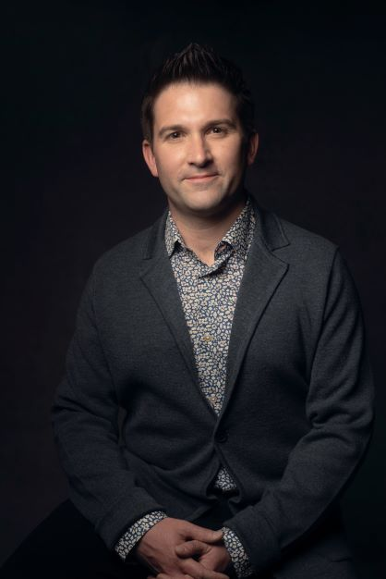Grammy-nominated, Barnaby Smith is Artistic Director of the internationally renowned vocal ensemble VOCES8, *LIVE From London* digital festivals, and the UK and US arms of The VOCES8 Foundation including its ensembles (Apollo5, Lyyra, The VOCES8 Foundation Choir), its Digital Academy and Milton Abbey International Festival and Summer School. Barnaby is in demand as a conductor, presenter, filmmaker, educator, countertenor and arranger.

Amongst a busy touring schedule with VOCES8 and ensembles around the world, recent projects have included Barnaby’s debuts conducting: Queensland Symphony Orchestra in Vaughan Williams and Tin which was awarded 5* by Artshub: “*The Lost Birds conducted with abundant energy and great detail”*; Nederlandse ReisOpera in Handel *Messiah:* Brahms *Ein Deutches* Requiem; the English Chamber Orchestra in Bach, Barber, Elgar and Faure; directing Jack Liebeck and VOCES8 in a new programme at a sold-out Sydney Opera House; directing and soloing in Bach Cantatas for Inon Barnatan’s La Jolla Summerfest; directingtwo solo-recordings *Handel & Bach* with the Illyria Consort*,* of which- Gramophone notes that there is “*no denying the refined beauty and sheer skill of Smith’s performance*” as well as producing and presenting the 14th *LIVE From London* Festival. Collaborations with Eric Whitacre and Paul Simon continued, resulting in two new albums – *Home* (reaching No.1 in the Classical Album chart and awarded a BBC Music Magazine Choral and Song Choice) and *Seven Psalms* (which garnered wide-ranging 5-star reviews and high praise from Rolling Stone magazine).

Upcoming conducting/solo projects include: opening Festival Bach de Lausanne in a programme from *Bach* with the Illyria Consort; conducting world premiere commissions for choir and orchestra by Jocelyn Hagen (*Rose Ever Blooming*) and Taylor Scott Davis (*Requiem Idyll*); conducting The VOCES8 Foundation’s 20th anniversary concert at the Barbican, London in June 2025; his debut conducting the Edvard Grieg Vokal Ensemble for The Bergen Kirkeautunnale. Barnaby is increasingly asked to present both for radio and television, regularly appearing on media platforms around the world.

Barnaby has performed at many of the world's prestigious festivals and halls including BBC Proms, Royal Albert Hall, the Barbican Centre, Wigmore Hall, Bridgewater Hall, Sydney Opera House, Muziekgebouw Amsterdam, La Seine Musicale and Cité de la Musique in Paris, Elbphilharmonie Hamburg, BOZAR in Brussels, Tokyo Opera City, NCPA Beijing, Mariinsky Theatre Concert Hall, Victoria Concert Hall in Singapore, Palacio de Bellas Artes in Mexico City and Vienna Konzerthaus.

Barnaby has conducted orchestras including the Philharmonia Orchestra, the Academy of Ancient Music, Australian National Academy of Music, English Chamber Orchestra, London Philharmonic Orchestra, Tokyo Philharmonic Orchestra, Monte Carlo Symphony and he directed the music for the Olympic Mascots Film Scores at Abbey Road Studios with the British Film Orchestra. He conducted the VOCES8 Foundation Choir and Orchestra in the premiere of Christopher Tin *The Lost Birds* alongside new arrangements of Eric Whitacre *Sleep*, Caroline Shaw *and the swallow*, and a new adaptation of *The Lark Ascending* for violin, choir, and orchestra.

Barnaby’s collaborations have included projects with Paul Simon, Rachel Podger, Roderick Williams, Christina Pluhar, Jack Liebeck, Masaki Suzuki, Jacob Collier, Ola Gjeilo, Eric Whitacre, Jonathan Dove and Christopher Tin amongst others. Digital collaborations have included The Sixteen, the English Chamber Orchestra, Gabrieli Consort & Players, The King's Singers, The Tallis Scholars, The Ringmasters, the Academy of Ancient Music and Chanticleer.

On disc Barnaby has released albums with record labels including Decca Classics, Universal, Sony, Warner, Naxos, Signum Classics and VOCES8 Records. He has six No.1 albums to his credit and has won numerous awards including Classic FM Album of the Year. He has released two solo albums on VOCES8 Records, *Handel,* with guest Mary Bevan in October 2021 and *Bach* with the Illyria Consort in February 2023. Barnaby conducted the Philharmonia for the world premiere recording of Mårten Jansson and Charles Anthony Silvestri's *Requiem Novum*.

Recent releases with VOCES8 include *Infinity* (Decca Classics), *After Silence* (VOCES8 Records) and *Home* (Decca Classics). Recent albums include Decca’s Christmas 2023 release *A Choral Christmas* on which Barnaby conducts festive works alongside Taylor Scott Davis’ *Magnificat*; *To Sing of Love* with Jack Liebeck and the VOCES8 Foundation Choir & Orchestra including Britten *Rejoice in the Lamb*, Vaughan Williams *The Lark Ascending* and Taylor Scott Davis *To Sing of Love.* Upcoming albums include *Nightfall* for Decca and Pergolesi *Stabat Mater* due in 2025*.*

Barnaby completed his studies in Specialist Early Music Performance at the Schola Cantorum Basiliensis where he was a pupil of Andreas Scholl and Ulrich Messthaler. He is an alumnus of the Britten-Pears Young Artists Programme and began his career singing as a treble in The Choir of Westminster Abbey.

A passionate pedagogue, Barnaby teaches regularly at Academies and Universities across the world, and co-curated the Master's course in ensemble singing at the University of Cambridge. Barnaby Smith is managed worldwide by Percius. [www.percius.co.uk](http://www.percius.co.uk)

*“’The Messiah’ which went with a swing both fresh and joyous — VOCES8 as Artists in Residence more than put their stamp on the festival… led by Barnaby Smith, a musical general who spearheaded all the musical endeavours and thus ensured quality in a class of its own… Jubilation and standing ovations at the close.”* Kultur, Graz

This biography is valid for use until September 2025.

We update our biographies regularly. For the most up-to-date version please email [info@percius.co.uk](mailto:hannah@percius.co.uk)